Prairie-Hills Elementary School District 144

Pre-K thru 5th

Pre-K thru 5th grade Student wear navy blue bottoms with a choice of navy or white shirts. The shirt needs to have a collar. A fully enclosed shoe solid color (black, brown, white, or navy) the laces should match the shoe.

[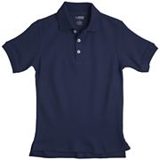](http://www.jcpenney.com/dotcom/month-long-values/kids/french-toast-piqu%c3%a9-polo-shirt---boys/prod.jump?ppId=1c66271&catId=cat1002790026&subcatId=cat1002790024&dimCombo=null&dimComboVal=null)[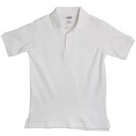](http://www.jcpenney.com/dotcom/month-long-values/kids/french-toast-polo-shirt---boys-4-7x/prod.jump?ppId=1c661d4&catId=cat1002790026&subcatId=cat1002790024&dimCombo=null&dimComboVal=null)[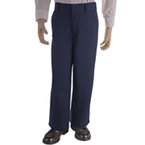](http://www.jcpenney.com/dotcom/kids/boys/dress-clothes/french-toast-flat-front-uniform-pants---boys-8-20/prod.jump?ppId=1c47aee&catId=cat1002790026&subcatId=cat1002790024&dimCombo=null&dimComboVal=null)[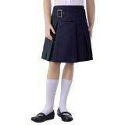](javascript:void(0))[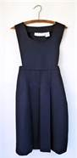](http://www.bing.com/images/search?q=navy+blue+school+uniforms&FORM=HDRSC2#view=detail&id=33CF23B1735CE98F14EA23AC94667A8E64725AE5&selectedIndex=16)

**6th thru 8th**

PHJH 6th thru 8th grade students wear khaki (tan) bottom, white shirts for 6th grade, yellow shirts for 7th grade and navy shirts for the 8th grade. The shirts need to have a collar. A fully enclosed shoe solid color (black, brown, white or navy) the laces should match the shoe.

[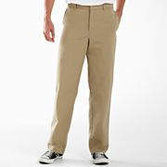](javascript:void('subCategory:cat1002790027');)[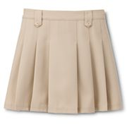](javascript:void('subCategory:cat1002790025');) [](http://www.jcpenney.com/dotcom/month-long-values/kids/french-toast-piqu%c3%a9-polo-shirt---boys/prod.jump?ppId=1c66271&catId=cat1002790026&subcatId=cat1002790024&dimCombo=null&dimComboVal=null) [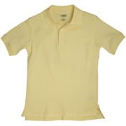](http://www.jcpenney.com/dotcom/month-long-values/kids/french-toast-polo-shirt---boys-4-7x/prod.jump?ppId=1c661d4&catId=cat1002790026&subcatId=cat1002790024&dimCombo=null&dimComboVal=null) [](http://www.jcpenney.com/dotcom/month-long-values/kids/french-toast-polo-shirt---boys-4-7x/prod.jump?ppId=1c661d4&catId=cat1002790026&subcatId=cat1002790024&dimCombo=null&dimComboVal=null)

8th 7th 6th